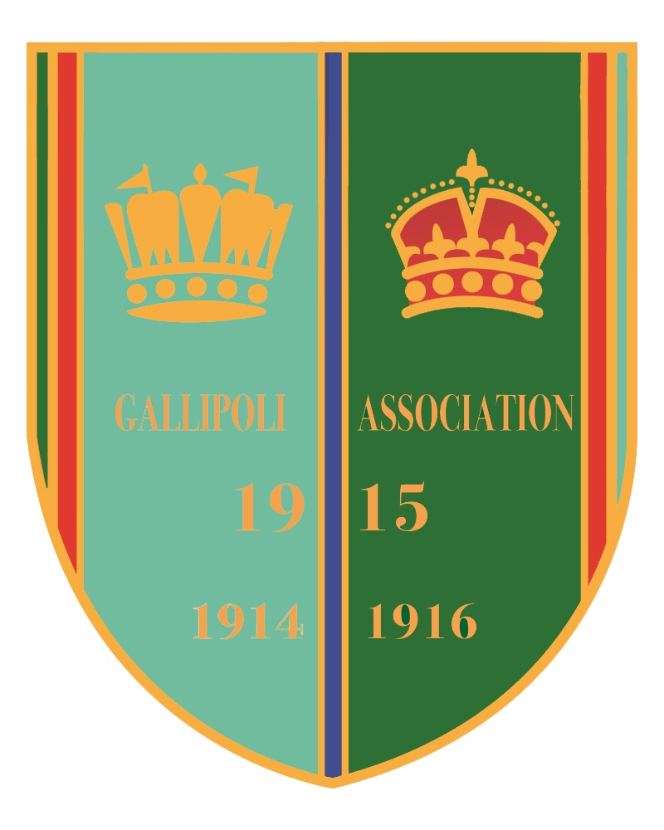
GALLIPOLI ASSOCIATION
CENOTAPH PRADE - SUNDAY 10TH NOVEMBER 2024
EARLY REGISTRATION ESSENTIAL

The Gallipoli Association will once again be offered the chance of representation at the March Past at the Cenotaph on Sunday 10th November 2024. This honour is open to members and their guests. The Royal British Legion will need to know names of those wishing to attend by the 18th of August.

Please register you interest as early as possible although it is understandable that your circumstances might change near to November.
These places are strictly limited and will be allocated on a “first come first served basis.”
An email address is essential for acceptance of a place.
Tickets will be despatched by email from the Royal British Legion in late October.

________________________________________________________________________

If you wish to take part, please complete the form below and either:
E-mail it to: events@gallipoli-association.org
Or Post it to: Hester Huttenbach, 24, Norcutt Road, Twickenham, Middlesex, TW2 6SR
A confirmation email will be sent on receipt.
________________________________________________________________________

I wish to apply for ________ ticket(s) to take part in the Cenotaph Parade on Remembrance Sunday, 10th November 2024
The following information is required. Please print clearly.

NAME __________________________________________________________________

(GUEST NAME)___________________________________________________________

ADDRESS_______________________________________________________________
______________________________________________POST CODE_______________

EMAIL_______________________________________________________(ESSENTIAL)

(GUEST’S EMAIL)_____________________________________________ (ESSENTIAL)

TEL. NO.________________________________________________________________

A Provisional Lunch booking will be made for after the Service. Further details to follow.
Would you like to reserve for lunch? YES / NO Please delete as required.

